

Tunku Abdul Rahman University Of
gManagement and Technology

BMCS2173
Graphics Programming
Character Prototype

Programme | : | Bachelor of Software Engineering (RSW3S1)
Tutorial Group | : | G3
Date Submitted to Tutor | : | 8th September 2025

Team Members:
No | Student Name | Student ID | Contribution (%) | Signature
1. | Yeoh Zhe Heng | 2307630 | 100% | 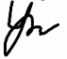
2. | Wong Pu Jin | 2307625 | 100% | WONG
3. | Loo Wai Kit | 2307599 | 100% | 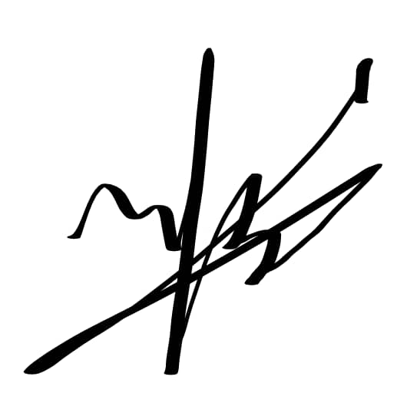
Total |  |  | 100 | -

No. | Team Member | Task(s) Allocated
1. | Yeoh Zhe Heng | - Idea BrainStorming  - Improve the sketch with polygon  - Revise Introduction in document  - Counts polygon on torso and head  - Draw weapon  - Actions/Animation brainstorming with opinion  - Setup project  - Include ortho view, perspective view  - Use openGl draw torso  - Use openGl draw head  - Use openGl connect everything  - Do action 1 (key ‘Z’)  - Include texture apply  - Action wrap-up
2. | Wong Pu Jin | - Idea Brainstorming with opinion  - Draw the initial sketch  - Check Grammar and term using in document  - Counts polygons for both arm  - Improve weapon drawing  - Actions/Animation brainstorming with opinion  - Determine code structure  - Use openGl draw arms  - Do action 2 (key ‘X’)  - Include lightning apply  - Testing for action wrap-up  - Do improvement on character (Increase polygon)
3. | Loo Wai Kit | - Idea Brainstorming with opinion  - Improve the sketch with polygon  - Documentation introduction  - Counts polygons for both leg  - Improve weapon drawing  - Actions/Animation brainstorming  - Determine global variable  - Use openGl draw legs  - Do action 3 (key ‘C’)  - Assist in lightning apply  - Testing for action wrap-up  - Do improvement on character (Increase polygon)

Declaration

We confirm that we have read and shall comply with all the terms and conditions of TAR University of Management and Technology’s plagiarism policy.

We declare that this assignment is free from all forms of plagiarism and for all intents and purposes is my own properly derived work.

Signature | : |  | WONG | 
Name | : | Yeoh Zhe Heng | Wong Pu Jin | Loo Wai Kit
Date | : | 25th Aug 2025 | 25th Aug 2025 | 5th Sep 2025

No | Student Name | Programme and Year of Study | Tutorial Group | Total Mark
1 | Yeoh Zhe Heng | RSW1S3 | G3
2 | Wong Pu Jin | RSW1S3 | G3
3 | Loo Wai Kit | RSW1S3 | G3

CLO3: Produce a 3D interactive graphics application using an appropriate graphics API. (P4, PLO3).
Criteria | Marks | Very Poor | Rating Very Poor to Excellent | Excellent | Comment
Teamwork & Completeness | 10 | Fail to work in a team and fail to integrate the application. Final model is incomplete and lots of bugs. | 1 2 3 4 5 6 7 8 9 10 | Able to work in a team to product a complete application. Final model is fully work and less bugs. Overall is well prepared.
Techniques Applied | 10 | No technique applied. | 1 2 3 4 5 6 7 8 9 10 | Complete techniques applied include texture and lighting.
Interactive Features | 10 | Model has no or limited interactive feature. | 1 2 3 4 5 6 7 8 9 10 | Model is very flexible. All parts are moving freely.
Viewport/ Projection | 10 | Only one default projection with no transformations. | 1 2 3 4 5 6 7 8 9 10 | Complete viewport with orthographic and perspective projections. Fully transformations for both views.
Animations | 10 | No animation or only one animation with very simple movement. | 1 2 3 4 5 6 7 8 9 10 | Good animation and complicated movement.
Model Design | 10 | Simple design with only using quadric. | 1 2 3 4 5 6 7 8 9 10 | Complicated design with variety of geometric primitives.
Complexity/ Primitive Count | 10 | Simple model with less than 200 polygon count. | 1 2 3 4 5 6 7 8 9 10 | Complex model with more than 500 polygon count.
Specific Features | 10 | Model has no specific features /customization and without weapon. | 1 2 3 4 5 6 7 8 9 10 | Model has a lot of specific features/customizations and weapons.
Documentation | 10 | Incomplete documentation. | 1 2 3 4 5 6 7 8 9 10 | Complete document with detail information
Personal appraisal / Presentation  (Individual) | 10 | Simple personal appraisal and poor presentation skill which unable to demonstrate the model clearly. | 1 2 3 4 5 6 7 8 9 10  1 2 3 4 5 6 7 8 9 10  1 2 3 4 5 6 7 8 9 10 | Detail personal appraisal and good presentation skill which able to demonstrate the model clearly with complete explanation.
 |  |  |  | Total [100]

Table of Content
Table of Content 6
Introduction 7
System Specification 8
1. Google search engine 8
2. LLM Research 9
3. Ipad Drawing 10
4. Visual Studio 10
5. OpenGL 10
6. Obj File and Bmp file Using 10
Design concept (sketch design for your character) 11
Front View 11
Back View 12
Side View 13
Weapon (Trident) 14
Orbit 15
Polygon counts 16
1. Torso 16
2. Head 17
3. Arms 18
4. Leg 19
5. Weapon 20
6. Sarong Draws 20
7. Orbits 20
8. Total 21
User manual 22
1. Walking 22
2. Weapon Equip and Animation 23
3. Animation Moves 24
4. Lightning 25
5. Texture, Armor and Wire frame 26
6. View changing (OP, MOUSE DRAG) 27
7. Reset Space ( spacebar ) 28

Introduction
This project focuses on creating an interactive 3D character using OpenGL. The concept is inspired by the recent success of Ne Zha 2, which performed exceptionally well at the box office. Following this success, the production team has decided to begin development on a sequel. For the new film, the director wants to introduce fresh characters that combine traditional Chinese mythology with elements from global legends. The goal is to create a richer, more diverse fantasy world that appeals to both local and international audiences.
One of the proposed characters is Poseidon, the ancient Greek god of the sea, storms, and earthquakes. Known for his great power and deep connection to nature, Poseidon brings a unique energy to the story. He wields a trident that controls the ocean and can cause massive destruction. In mythology, Poseidon is one of the twelve Olympians, the brother of Zeus and Hades, and the son of the Titans Cronus and Rhea. He is also the father of many legendary creatures, including the winged horse Pegasus. His bold and unpredictable personality makes him an ideal candidate for a story filled with drama, mystery, and magic.
Bringing Poseidon into the Ne Zha universe creates the chance for a powerful cultural crossover. Ne Zha is deeply rooted in Chinese mythology, while Poseidon comes from Greek tradition. Together, they can represent a larger theme: that myths from around the world share common origins. There are ancient legends in many cultures about powerful beings who protect or challenge the world. In some stories, these figures are creators. In others, they are warriors or guides. This shared theme can be woven into the plot of the sequel. It can suggest that gods like Nüwa, Adam, and Poseidon may all be different faces of the same ancient power which are known by many names across time and place.
In this imagined world, the sea god Poseidon might appear as a mysterious outsider, entering Ne Zha's world through a rift between dimensions or as part of a prophecy. He could begin as an enemy, misunderstood and feared, but gradually reveal a deeper connection to Ne Zha’s journey. Perhaps both characters share a common mission: to restore balance in a world where ancient forces are waking up and colliding. This opens up many storytelling possibilities which conflict, alliance, and even philosophical questions about destiny, identity, and the unity of cultures. Visually and thematically, Poseidon can add depth to the sequel. His design can include traditional Greek elements like the trident, oceanic armor, and flowing water effects while blending with Chinese art styles to create a fresh, hybrid aesthetic. His presence can introduce new visual environments, such as underwater kingdoms or storm-filled battlegrounds, enhancing the cinematic and creative scope of the project.
The objective of this project:
- Create a 3D character model of Poseidon using OpenGL.
- Include a custom weapon, such as a trident.
- Use OpenGL transformations to animate the full body. The arms, legs, head, and body should all be able to move.
- Add textures and lighting to improve the visual quality.
- Use both orthographic and perspective views to show the character from different angles.
- Add special features or effects to increase interaction and visual interest.

This project will show how graphics programming and storytelling can work together. It also gives a chance to explore creative ideas while practicing animation and 3D design skills.

System Specification

Google search engine
To develop the 3D character prototype of Poseidon, we used a combination of tools and resources throughout the design and conceptual phases. First, we used the Google search engine to collect initial information about Poseidon, including visual references, mythology background, and concept art. This helped us understand how Poseidon is commonly represented, such as his trident, ocean-themed armor, and facial features. Google also provided access to a front-facing 3D view of Poseidon, which gave us a good starting point. However, the available references were limited, mostly showing only the front view, which was not enough to fully visualize the character from all angles.
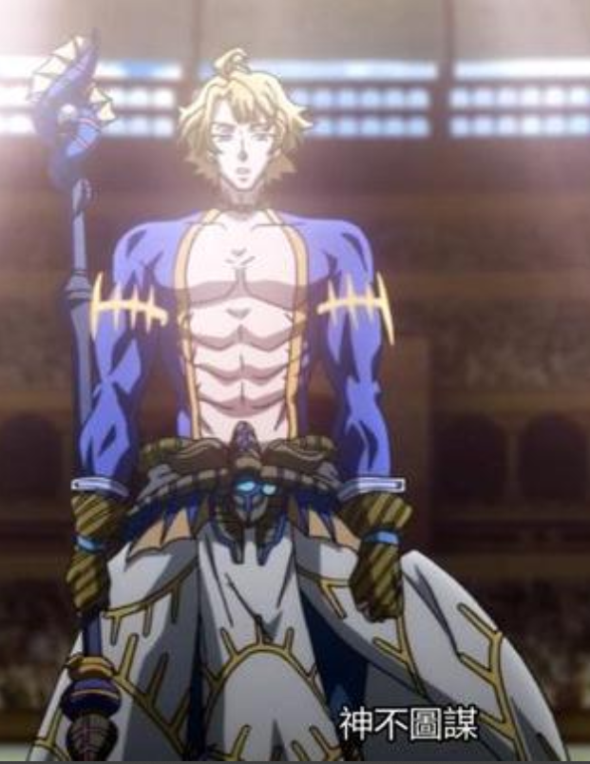
Figure 2.1: Google prototype

LLM Research
To overcome the limitation mentioned above, In this phase, we used both ChatGPT and Gemini to help generate abstract ideas for the side and back views of the character. These views were not clearly available from online visual references, so using language models allowed us to complete the concept needed for drawing the full prototype. We conducted several prompt-based conversations to gather the required information and refine the visual details from different perspectives. By using both LLMs (Large Language Models), we were able to improve the accuracy of the abstraction process and explore a wider range of creative ideas. This approach ensured a more complete and balanced character design before moving on to the drawing and modeling phases.
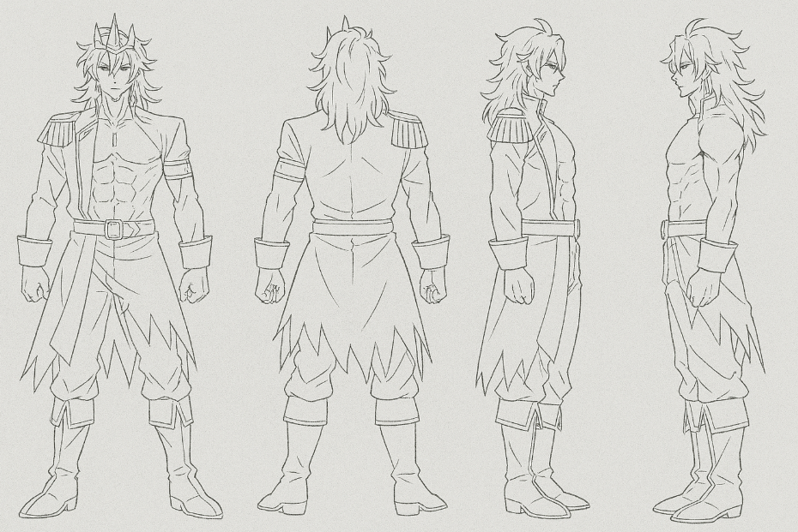
Figure 2.2: ChatGPT Refinement 1

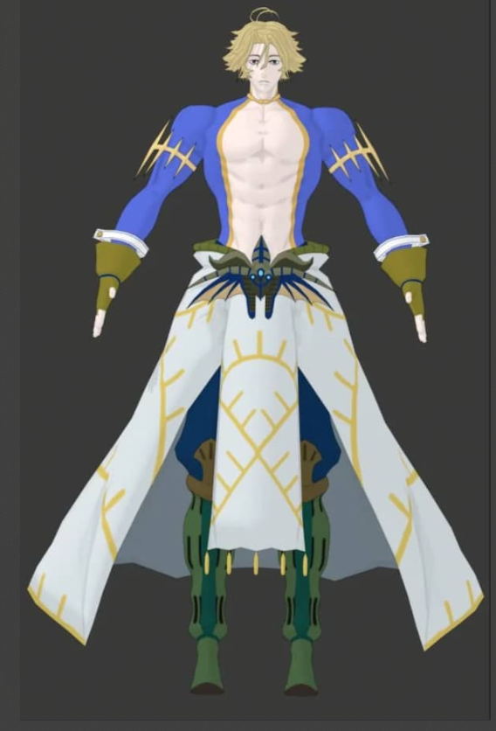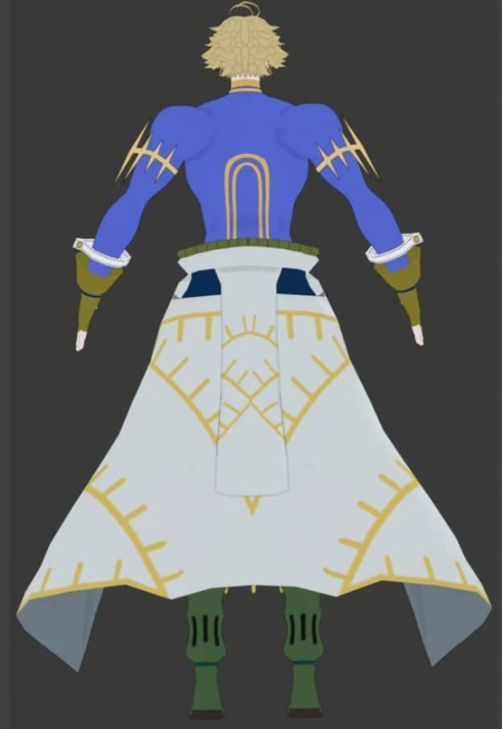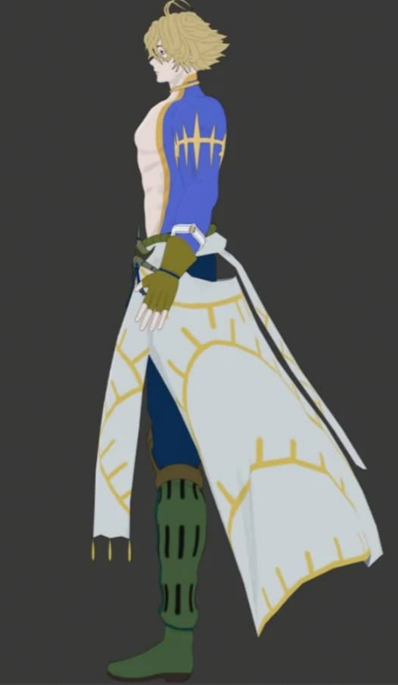
Figure 2.3: ChatGPT Refinement 2

Ipad Drawing
Once we had enough abstract references, we moved on to iPad drawing to manually sketch the final design. This phase was important to ensure that our Poseidon character was entirely original and not copied from any existing source. By redrawing the character based on the ideas generated through search and AI, we created a new version with our own design elements and improvements. This not only helped us avoid plagiarism or copyright issues but also allowed us to take full ownership of the creative process. The final drawing served as the visual reference for the 3D modeling stage.

Visual Studio
This project was developed using the Visual Studio IDE together with the C++ SDK. Visual Studio provides a simple way to set up windows, manage libraries in the linker, and handle multiple codes in one place. The familiar environment of C++ made it easier for us to start quickly. With this advantage, we built a working prototype faster than expected. Visual Studio also offers many built-in tools and libraries, such as vector and math functions, which support the development process. These features helped us work more efficiently and stay focused on the core design.

OpenGL
This project focuses on using the Application Programming Interface (API) from OpenGL. We applied opengl32.lib and glu32.lib to create the character efficiently. The opengl32.lib library provides core functions such as glBegin, which is used to draw quads, triangles, lines, and more. The glu32.lib library adds higher-level functions, such as utilities for handling textures, lighting, and other graphical effects. We fully utilized both libraries to achieve the intended features and outcomes of the project.

Obj File and Bmp file Using
OBJ files are a common 3D model format used to store geometry data such as vertices, edges, and surfaces. They are widely supported and allow developers to import ready-made models into a project.
BMP files are bitmap image files that store pixel data without compression. They are often used as textures in graphics applications because of their simplicity and compatibility.
In this project, we used OBJ files to speed up the creation of objects other than the main character. For example, we imported an orbit model from free online sources, which helped reduce development time. We also applied BMP files as textures to improve the visual quality of our character. These textures enhanced realism and supported our goal of achieving a more natural and lifelike appearance.

Design concept (sketch design for your character)

Front View
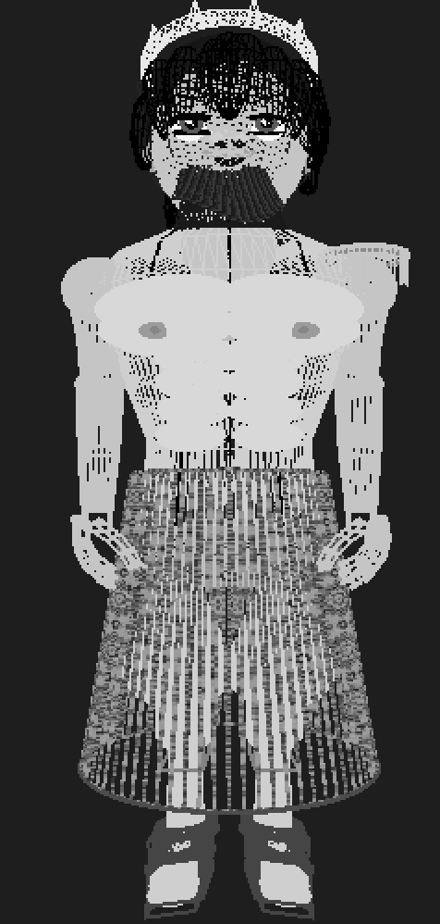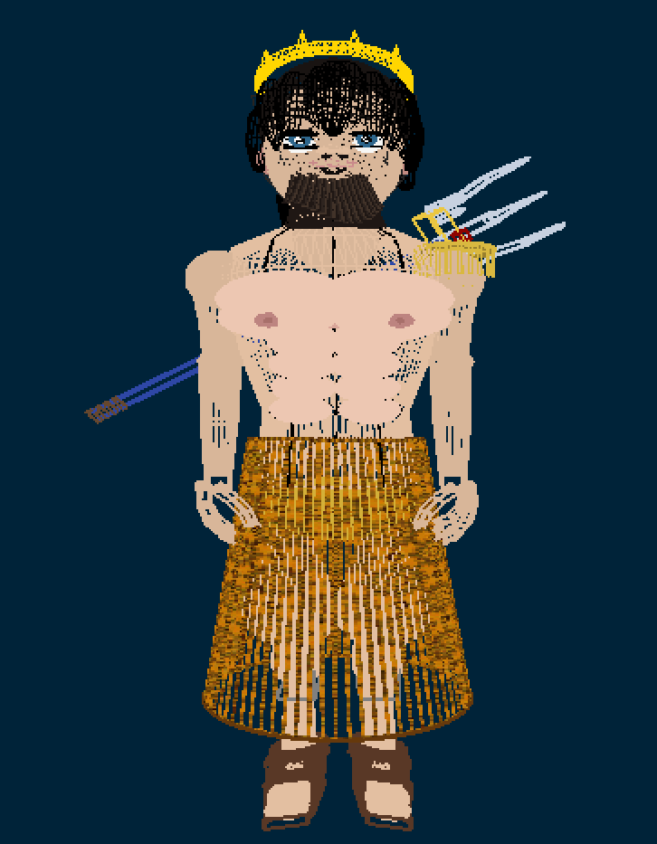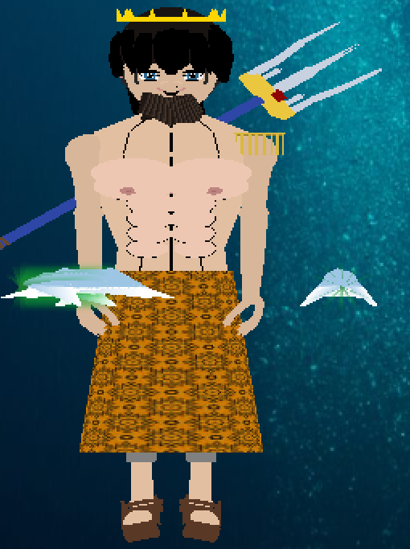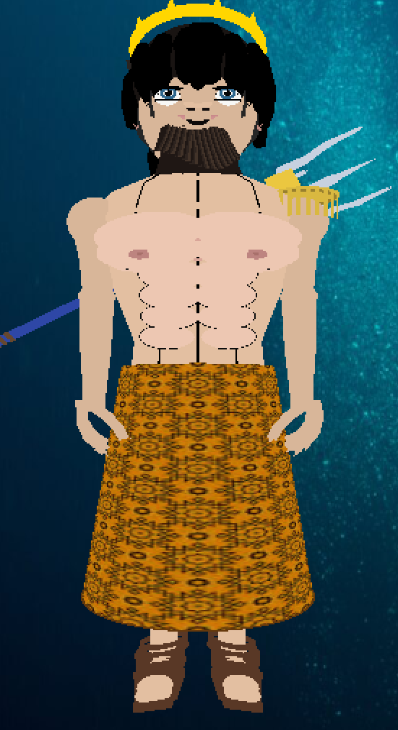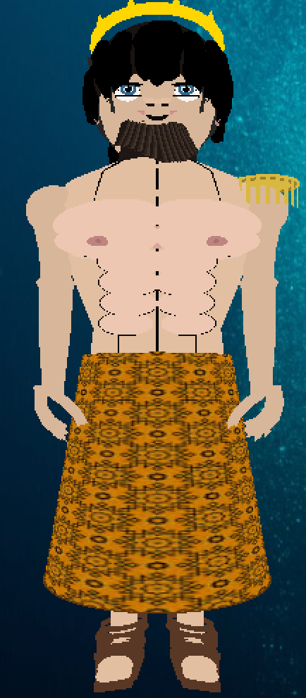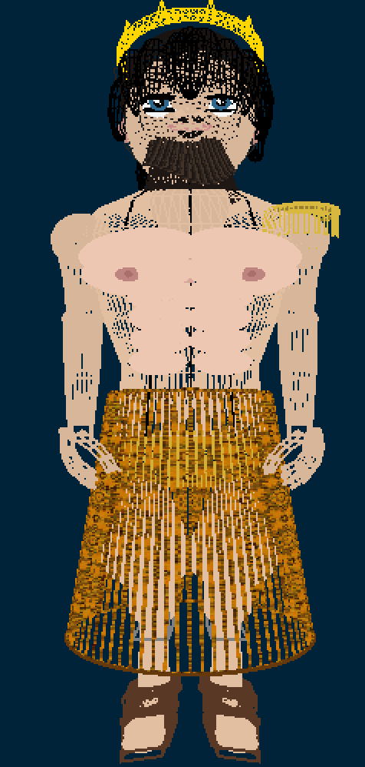
To achieve our ideal appearance for the character, we incorporated several deliberate design choices. The addition of a beard and a more realistic torso gave the figure a more authentic look, while Roman Caligae sandals were selected for the footwear to align with the character's classical inspiration. A crown was also included to symbolize Poseidon's status as the king of the ocean. Furthermore, we designed an accompanying whale with a green flame as a unique orbiting element. The character will consistently carry a Trident on his back, a key weapon that can also be armed for combat.

Back View
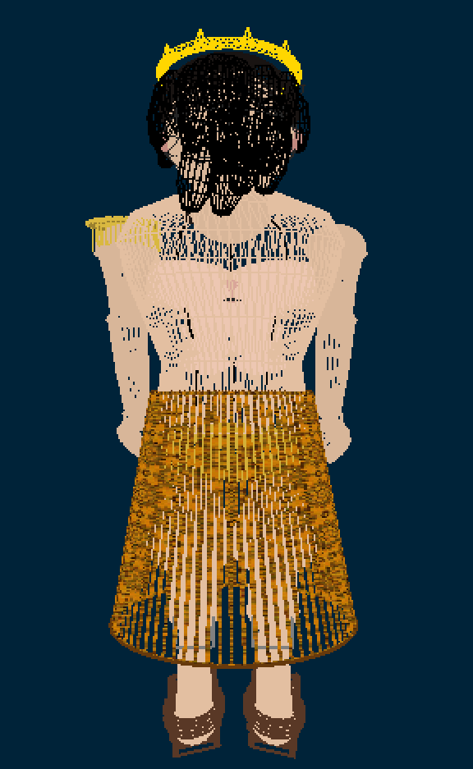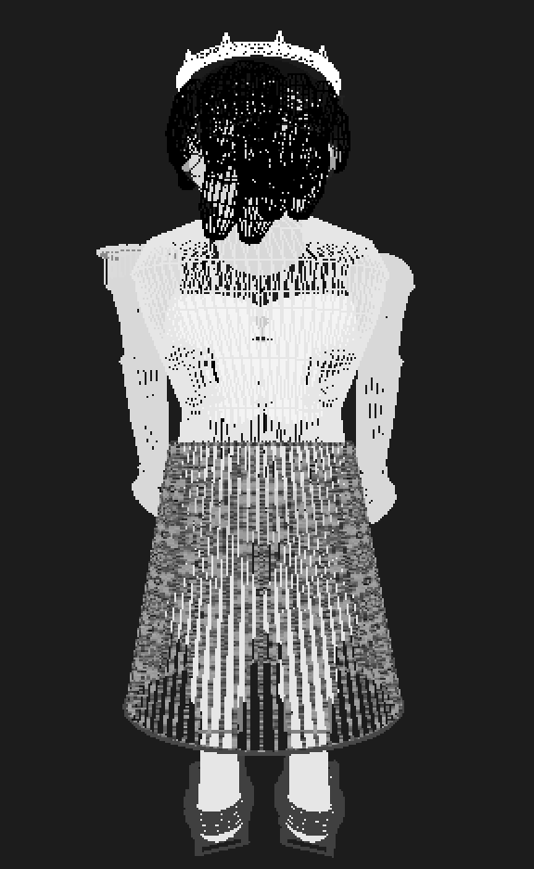
Since our design focused primarily on the front of the character, we kept the back view simple. It was modeled to be anatomically correct to maintain a realistic and naturalistic appearance. The design of the back is consistent with the front, ensuring a cohesive and unified look for the entire model.

Side View
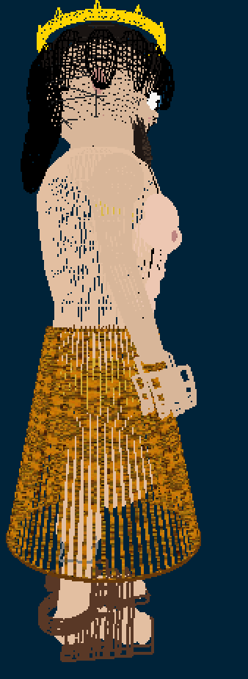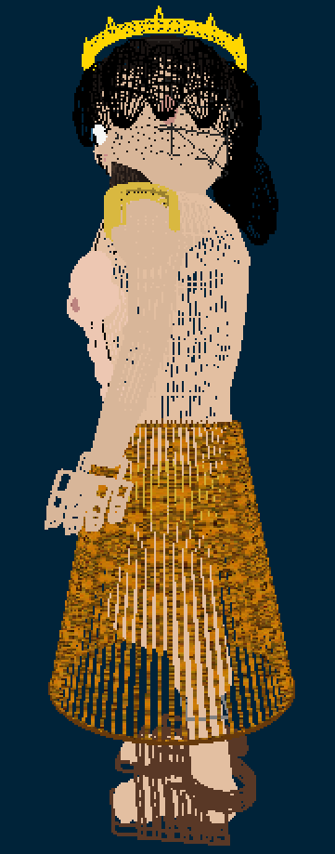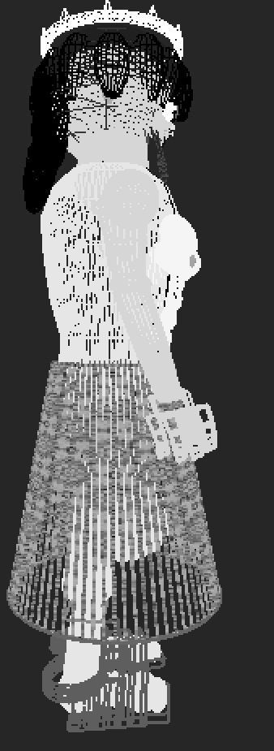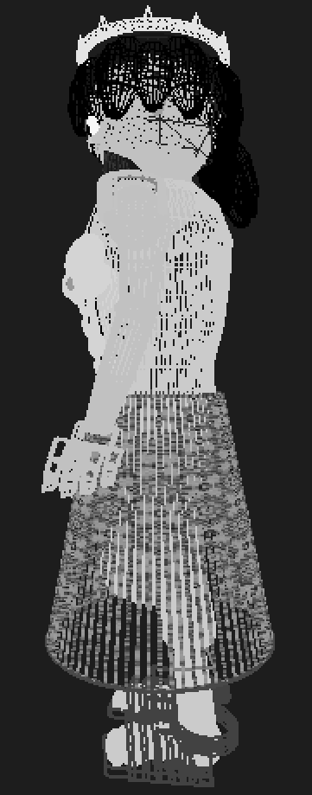
The side view is the crucial link connecting the front and back of the character model. While both sides are fundamentally similar, one side will uniquely feature a paulette to add a distinct design element. The side view is critical for ensuring a seamless and coherent transition between the front and back of the character.

Weapon (Trident)
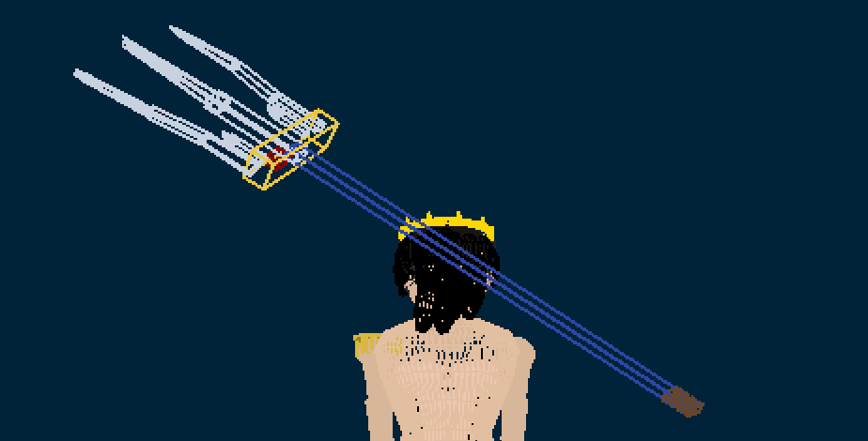
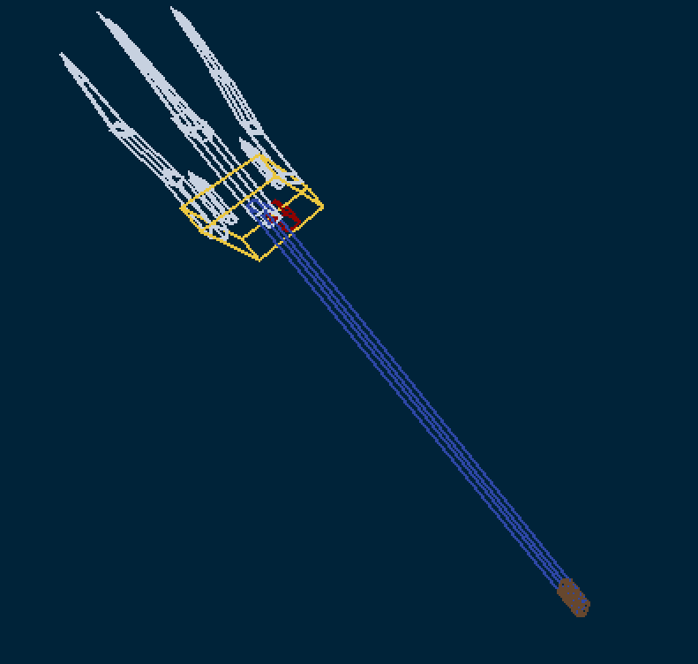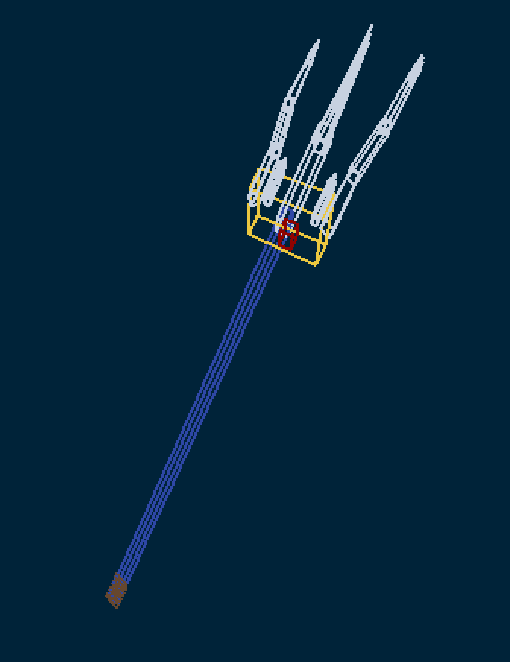
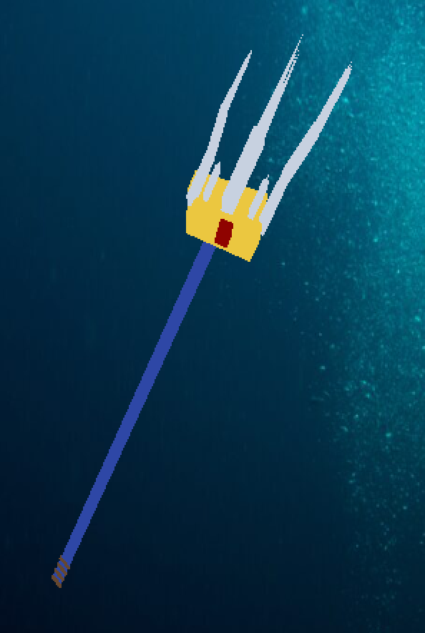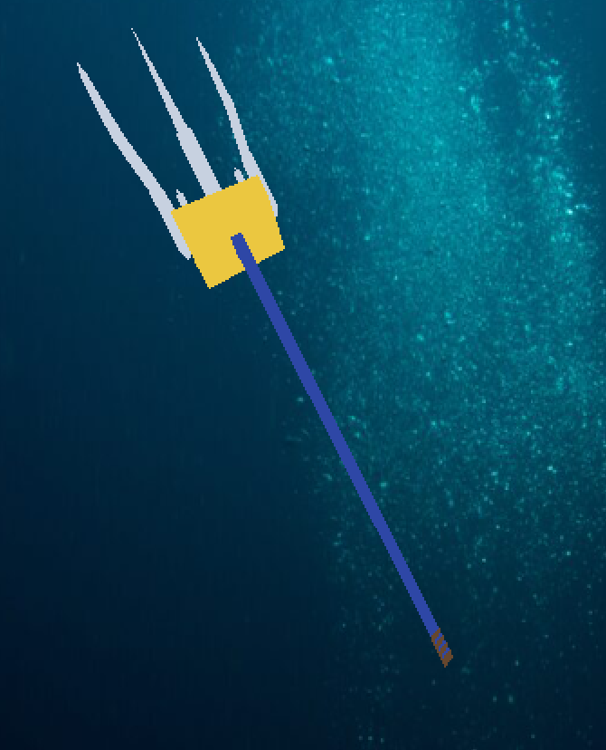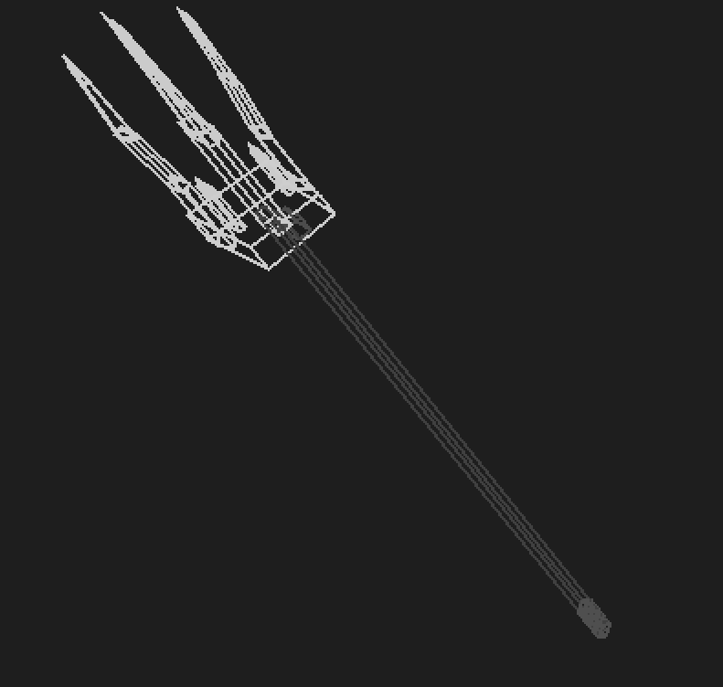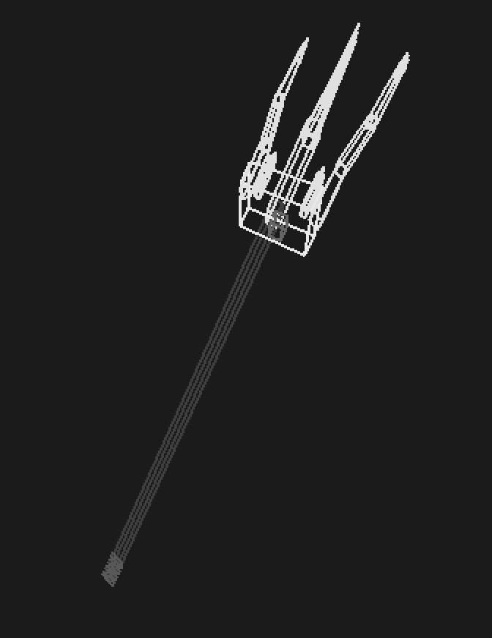
The Trident, Poseidon's weapon, is a key part of the character's design, featuring a mix of textures and materials.
The center and side spears are a shining silver texture, while the central part of the head is a bold gold texture. A striking red ruby gem is set in the middle, and it also has a custom texture applied to it. The handle is wrapped with four rounds of string and uses a blue gem texture, giving it a reflective, shimmering effect.

Orbit

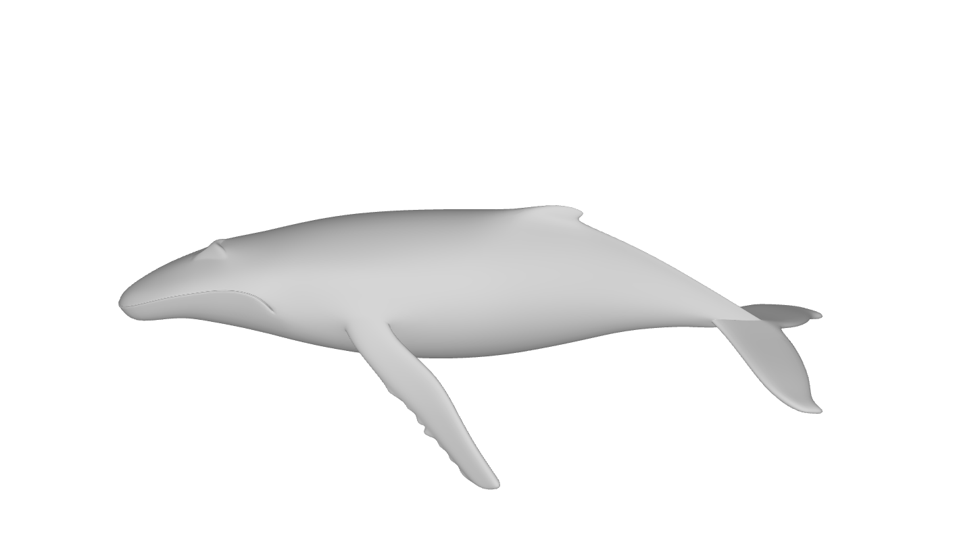
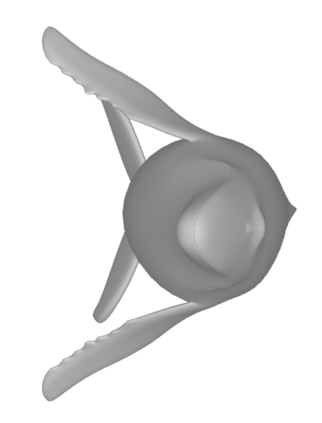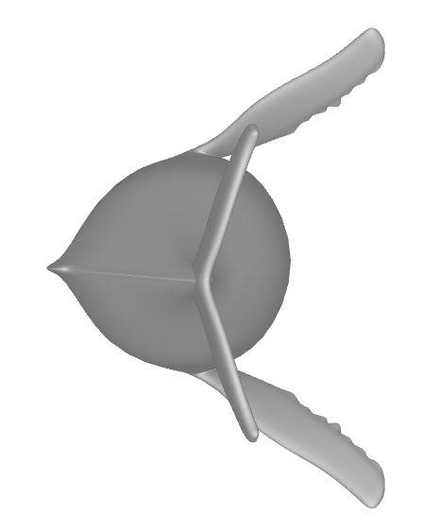
For the orbit, we will be creating a smooth, stylized whale model using Blender . This will not only give the orbit a clean look but also serve as a valuable learning experience. The design will be kept simple, featuring a two-tone color scheme of light blue and white. The whale will orbit Poseidon, visually reinforcing his status as the king of the sea.

Polygon counts
drawSphere that is drawn by GL_TRIANGLE_STRIP formula:
Polygons per Stake: Using the GL_TRIANGLE_STRIP rule, the number of triangles in a single strip/Stake is its total vertices minus two.
  - Polygons per strip = (2×(slices+1))−2
  - =(2×slices+2)−2
  - =2×slices
Final Calculation in order to get the total number of polygons, you multiply the number of polygons per strip by the number of strips.
Total Polygons = (Polygons per Strip) × (Number of Strips)
OR
Total Polygons = (2×slices)×stacks
drawCylinder that is drawn by GL_TRIANGLE_STRIP formula:
(2×slices×stacks)+caps
GL_TRIANGLE_STRIP having loop on 2 vertices every slices, count by formula: 2 * slices

Torso
Function (Polygon Per Function) | Using counts | Sub-total Polygons
drawSphere [7 stacks, 9 slices] (126 polygon) | 1 | 42
drawSphere [8 stacks, 8 slices] (128 polygons) | 2 | 256
drawSphere [18 stacks, 18 slices] (648 polygons) | 9 | 5832
drawSphere [28 stacks, 28 slices] (1568 polygons) | 2 | 3136
GL_QUADS (1 polygon) | 240 | 240
GL_TRIANGLES (1 polygon) | 72 | 72
Total: |  | 9578

Head
Function (Polygon Per Function) | Using counts | Sub-total Polygons
drawCylinder [1 stacks, 20 slices] (42 polygons) | 1 | 42
drawSphere [8 stacks, 8 slices] (128 polygons) | 1 | 128
drawSphere [18 stacks, 18 slices] (648 polygons) | 4 | 2596
drawSphere [20 stacks, 20 slices] (800 polygons) | 4 | 1600
drawSphere [22 stacks, 22 slices] (968 polygons) | 2 | 1936
drawSphere [26 stacks, 26 slices] (1352 polygons) | 2 | 2704
drawSphere [28 stacks, 28 slices] (1568 polygons) | 1 | 1568
drawSphere [36 stacks, 36 slices] (2592 polygons) | 1 | 2592
drawRingZ (1 polygon) | 2 | 2
drawRingZ (1 polygon) | 4 | 4
Nose Half [12 stacks, 16 slices, use GL_QUADS] (48 polygons) | 2 | 96
Nose Tip (1 polygon) | 2 | 2
Nostrils ( 2 polygons) | 1 | 2
BeardClump [8 GL_QUADS, 1 GL_TRIANGLE] (9 polygons) | 194 | 1746
Root Ring (Hair) GL_QUADS (1 polygon) | 36 | 36
tubeSectionQuads [18 Slices, use GL_QUADS] (18 polygons) | 84 | 1512
Hair Lobe [A circle] (1 Polygon) | 28 | 28
drawCrown [30s 12 GL_TRIANGLES, 30s 8 GL_TRIANGLES] (600 polygons) | 1 | 600
Total: |  | 17194

Arms
Note: Count 1 leg then multiple 2 at the end
Function (Polygon Per Function) | Using counts | Sub-total Polygons
quadBox (6 polygons) | 1 | 6
quadFingerSegment (4 polygons) | 15 | 60
GL_TRIANGLE (1 polygon) | 5 | 5
tubeSectionQuads [20 Slices, use GL_QUADS] (20 polygons) | 9 | 180
Sub-Total (To multiple 2): |  | 251 * 2
Total: |  | 502

Leg
Note: Count 1 leg then multiple 2 at the end
Function (Polygon Per Function) | Using counts | Sub-total Polygons
drawCylinder [1 stacks, 28 slices] (42 polygons) | 1 | 58
quadSegment (4 polygon) | 1 | 4
drawSphere [16 stacks, 16 slices] (512 polygons) | 1 | 512
drawSphere [18 stacks, 18 slices] (648 polygons) | 1 | 648
drawSphere [20 stacks, 20 slices] (800 polygons) | 1 | 800
drawSphere [28 stacks, 28 slices] (1568 polygons) | 5 | 7840
Sub-Total (To multiple 2): |  | 9862 * 2
Total: |  | 19724

Weapon
Function (Polygon Per Function) | Using counts | Sub-total Polygons
quadBox (6 polygons) | 16 | 96
triWedgeTip ( 4 polygons) | 4 | 16
Total: |  | 112

Sarong Draws
Function (Polygon Per Function) | Using counts | Sub-total Polygons
GL_TRIANGLE_STRIP loops [2 vertices once slice, 72 slices] (144 polygons) | 2 | 288
GL_TRIANGLE_FAN loops to form circle (1 polygon) | 1 | 1
Total: |  | 289

Orbits
Function (Polygon Per Function) | Using counts | Sub-total Polygons
Draw Obj (1 polygon) | 3 | 3
Draw lighting flame (1 polygon) | 3 | 3
Total: |  | 6

Total

No. | Parts | Polygon Count
1 | Torso | 9578
2 | Head | 17194
3 | Arm | 502
4 | Leg | 19724
5 | Weapon | 112
6 | Sarong Draws | 289
7 | Orbits | 6
Grand Total: |  | 47405

User manual

Walking

Keyboard Input | Descriptions
W | When the 'W' key is pressed, the character's idle state shifts into a realistic forward walk. The animation and footstep sounds are triggered simultaneously, creating a convincing sense of motion. This continues as long as the key is held.
A | When the 'A' key is pressed, the character's idle state shifts into a realistic leftward walk. The animation and footstep sounds are triggered simultaneously, creating a convincing sense of motion. This continues as long as the key is held.
S | When the 'S' key is pressed, the character's idle state shifts into a realistic backward walk. The animation and footstep sounds are triggered simultaneously, creating a convincing sense of motion. This continues as long as the key is held.
D | When the 'D' key is pressed, the character's idle state shifts into a realistic rightward walk. The animation and footstep sounds are triggered simultaneously, creating a convincing sense of motion. This continues as long as the key is held.

Weapon Equip and Animation

Keyboard Input | Description
B | Pressing the 'B' key equips the Trident from the character's back to their right hand. Pressing it again while holding the weapon will re-holster it to the character's back.
Z | When the 'Z' key is pressed, an armed character will jump and perform a circular weapon swing. This forward attack is accompanied by a realistic sound effect and a swirling, "loop hole" visual effect that appears in front of the character.
X | Holding the 'X' key makes an armed character begin to charge an attack, indicated by a visual vibration effect. When you release the key, the character performs a sweeping motion, generating a powerful shockwave. This action is accompanied by a custom sound effect.
C | When you press the 'C' key, the armed character raises their weapon. The weapon then fires approximately 20 projectiles at once. These projectiles are "bubble-like" in appearance and are accompanied by a distinct shooting sound effect.

Animation Moves

Keyboard Input | Description
1 | Pressing the ‘1’ key will rotate the wrist, when the character is not armed up.
2 | Pressing the ‘2’ key will move up the elbow joint point, pressing again will move back down the elbow joint point, when the character is not armed with a weapon and Shoulder Joint Point not up to 180Deg.
3 | Pressing the ‘3’ key will move up the shoulder joint point 90 Deg, pressing again will move back down the shoulder joint point, when the character is not armed with a weapon.
3 | Pressing the ‘4’ key will move up the shoulder joint point 180Deg or 120Deg, pressing again will move back down the shoulder joint point, when the character is not armed with a weapon.
5 | Pressing the ‘4’ key will do the head animating, the odd sequence of pressing will shake the head horizontally, the even sequence of pressing will shake the head vertically.
6 | Pressing the ‘5’ key will march on the ground.
7 | Pressing the ‘6’ key will squat down when the character is not bowed (‘8’ key action), pressing again will stand back up.
8 | Pressing the ‘7’ key will do a jumping action where the character squat down and jump, then land on the ground. It can be done when the character is not squatted and bowed.
9 | Pressing the ‘8’ key will do the bow action, where bowing down, pressing again will back to normal state. It can be executed when no weapon is on hand and is not squatted.
0 | Pressing the ‘9’ key will change the sequence of the orbit rotating, there will be total in 3 forms. The changes triggered in sequence order.

Lightning

Keyboard Input | Description
L | Pressing the 'L' key turns on the lighting effect. This key indicates whether other keys are working or not.
Y | Pressing the 'Y' key shifts the light focus to the front.
I | Pressing the 'I' key shifts the light focus to the back.
U | Pressing the 'U' key shifts the light focus upward.
J | Pressing the 'J' key shifts the light focus downward.
H | Pressing the 'H' key shifts the light focus to the right side.
K | Pressing the 'K' key shifts the light focus to the left side.

Texture, Armor and Wire frame

Keyboard Input | Description
N | Pressing the 'N' key cycles through a series of five different character skin textures. Each press changes the character's appearance to the next look in the sequence. The five options are:  - Normal: The default, regular skin texture.  - Army Style: A camouflage or military-themed texture.  - Wooden Style: A texture that gives the character a wood-like appearance.  - Brick Style: A texture that makes the character look like they are made of bricks.  - Army Style 2: A second variation of the army-themed texture.
V | Pressing the ‘V’ key will arm up the armor on the body and hand, pressing the key again will unequip the armor which will return to normal state. It can be triggered when the wire frame mode is not on.
‘-’ OR VK_OEM_MINUS | Pressing the ‘0’ key will enable wire frame mode where the whole character will show only the line in order to view how the character is built and those detailed applications.

View changing (OP, MOUSE DRAG)
Keyboard Input / Mouse Action | Description
Mouse Drag | Dragging the mouse changes the character’s viewing angle based on the direction of movement:  - Right Drag: Rotates the character to the left, revealing the left-side view.  - Left Drag: Rotates the character to the right, revealing the right-side view.  - Upward Drag: Tilts the character downward, shifting to a top-side view.  - Downward Drag: Tilts the character upward, shifting to a bottom-side view.
O | Pressing the 'O' key switches the display to an orthographic view.
P | Pressing the 'P' key switches the display to perspective view.
T | Pressing the 'T' key zooms in, but only when the perspective view ('P') is active.
G | Pressing the 'G' key zooms out, but only when the perspective view ('P') is active.
[ OR VK_OEM_4 OR 0xDB | Pressing ‘[‘ key will change the near plane to view more nearer when in Perspective view.
] OR VK_OEM_6 OR 0xDD | Pressing ‘]‘ key will change the far plane to view more further when in Perspective view.
, OR VK_OEM_PERIOD | Pressing ‘,‘ key will change the camera view rotating counterclockwise on the y-axis when in Perspective view.
. OR VK_OEM_COMMA | Pressing ‘.‘ key will change the camera view rotating clockwise on the y-axis when in Perspective view.
; OR VK_OEM_1 | Pressing ‘;‘ key will change the camera view rotating counterclockwise on the x-axis when in the perspective view.
‘ OR VK_OEM_7 | Pressing ‘’‘ key will change the camera view rotating clockwise on the x-axis when in the perspective view.
VK_LEFT | Pressing the VK_LEFT key will change the camera to rightward, where the character will move to the left.
VK_RIGHT | Pressing the VK_RIGHT key will change the camera to leftward, where the character will move to the right.
VK_UP | Pressing the VK_UP key will change the camera to downward, where the character will move to the top.
VK_DOWN | Pressing the VK_DOWN key will change the camera to downward, where the character will move to the bottom.

Reset Space ( spacebar )

Keyboard Input | Description
Spacebar | Pressing the Spacebar resets the entire scene. The character and the environment are both returned to their default, starting positions, allowing for a fresh start.

